FACT SHEET

Shipping Containers on Your Property

Use of shipping containers
Shipping containers have become more readily available in recent years due to an increased supply of second-hand containers from transport companies. As a result, they are frequently used as a low-cost and secure storage option and have become increasingly popular within Buloke Shire.
The absence of clear and consistent guidelines governing the use of shipping containers has resulted in Council experiencing a rise in compliance and enforcement issues relating to the unauthorised placement of shipping containers. This fact sheet has been developed to assist both Council and landowners by providing clarity on the appropriate use, siting and management of shipping containers.
Depending on the circumstances, the placement and use of a shipping container may require a planning permit and/or a building permit.

Short term use/placement
Neither planning nor building permits are required for the short-term use of a shipping container. Examples of short term uses include:
- Short Term (up to 3 Months) storage of house contents when relocating.
- Storage of material and equipment during construction
- Loading of goods for shipping purposes
Note: Short term use may require a Local Law Permit

Long term use/placement
Building permits are generally required for the long-term placement and use of a shipping container, whether for storage or conversion into a structure such as a tiny house, office, café, or other occupiable space.
In addition, a planning permit may be required depending on the property's zoning classification and any applicable overlays (such as heritage, environmental, or flood overlays).
It is recommended that property owners consult Council to confirm specific permit requirements prior to installation or construction.

Planning Permits
Whether a shipping container requires a planning permit depends on several factors, including:
- The zoning and any overlays applying to the land (refer to the Planning Property Report: https://www.planning.vic.gov.au/planning-schemes/planning-property-report)
- The proposed use of the shipping container (e.g. storage, accommodation or retail purposes)
- The existing use of the land
- The length of time the container is to be located on the land (short-term, medium-term, long-term or permanent)
Domestic
A planning permit is generally required on residential land where a shipping container is proposed:
- As a self-contained second dwelling
- As a shed on vacant land
- Where a planning overlay applies that triggers the need for a permit
- For commercial or business purposes
A planning permit is generally not required where the shipping container is associated with an existing dwelling and is used:
- As a storage unit
These requirements may vary depending on the applicable zoning and overlays. A building permit is required in all circumstances.
Commercial and Industrial
A planning permit is required for the buildings and works associated with the placement of a shipping container.
The use of shipping containers on commercial or industrial land for any purpose other than short-term loading or unloading of goods for shipping, or within a designated shipping container storage facility, may require a planning permit.
Planning Permit application
To apply for a Planning Permit go to the Greenlight Portal
A planning permit application will require the following to be submitted:
- Title Documents
- Plans – site plan, floor plan, elevation plan
- Written submission detailing the proposal
A letter requesting the application fee will be sent after the initial assessment.
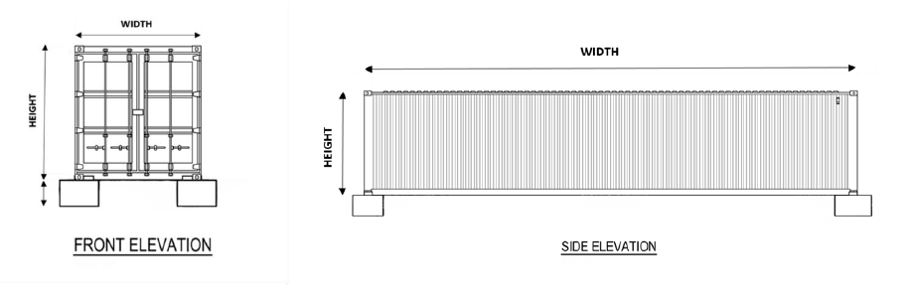

Building Permits
There are regulations that govern the use of shipping containers on private land. A shipping container to be used as a store, habitable room, dwelling or any other use, will be a classifiable building under the National Construction Code and the Building Regulations 2018.
A building permit is required to place a shipping container on properties for medium- or long-term use.
Domestic
Examples requiring a building permit on domestic properties include:
- use as a dwelling
- use as a habitable or non-habitable outbuilding
- use as a shed, storage or similar
Commercial and Industrial
Shipping containers used on commercial properties for any purpose other than short term loading of goods for shipping purposes or in designated container storage facilities, require a building permit.
Building Permit Application
To obtain a building permit for the permanent/long term placement of a shipping container, you need to submit plans that include a site plan and information about:
- Roofing design – including stormwater collection and drainage
- The footings supporting the structure – engineered footing design plan
Example of a Footing Plan

Note: If the container requires a permit, it must comply with the requirements of the Building Regulations and all the relevant parts of the National Construction Code. Where the Relevant Building Surveyor is not satisfied that the appropriate information has been provided, then they cannot issue the building permit.

