🌳 FACT SHEET

Victorian Planning Scheme – Clause 52.37 Canopy Trees
Amendment VC289 | Approved 15 September 2025
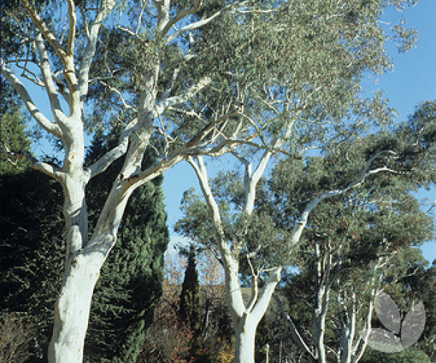

Background
On 15 September 2025, the Victorian Government approved Amendment VC289, introducing Clause 52.37 – Canopy Trees into all Victorian planning schemes.
The amendment implements Action 12 of Plan for Victoria, aiming to protect and enhance urban tree canopy across the state.
Large canopy trees play a critical role in:
- Reducing urban heat
- Supporting biodiversity
- Improving neighbourhood character
- Enhancing climate resilience

What Has Changed?
Clause 52.37 now requires a planning permit to remove, destroy or lop a canopy tree in specified circumstances on residential land.
If you are planning to remove or significantly prune a large tree, you may now need Council approval.

What Is a Canopy Tree?
A canopy tree is a tree that meets all three of the following:
✔ Taller than 5 metres (measured from ground level)
✔ Trunk circumference greater than 0.5 metres, measured at 1.4 metres above ground level
✔ Canopy diameter of at least 4 metres
If a tree meets these dimensions, it is classified as a canopy tree under Clause 52.37.

When Do I Need a Permit?
If your property is in the Township Zone, you will generally need a planning permit in these common situations:

1. Vacant Residential Land
A permit is required to remove or lop any canopy tree anywhere on the lot.

2. Existing Dwelling on the Lot
A permit is required if the canopy tree is located:
- Within 6 metres of the narrowest street frontage, or
- Within 4.5 metres of the rear boundary

3. Land with a Permit Application for New Dwellings
The same 6 metre and 4.5 metre distances apply as above.

What Does “Lop” Mean?
“Lopping” generally refers to significant pruning that removes substantial branches or canopy.
Routine maintenance pruning may not always require a permit, but major canopy reduction is likely to.
Always confirm with Council’s planning department before undertaking works.

Are There Any Exemptions?
Some exemptions may apply, including where a tree:
- Is dead
- Presents an immediate risk to safety
- Must be removed under another Act
Exemptions are specific and should be confirmed with Council’s planning department prior to works.

What Should Property Owners Do?
If you are considering removing or pruning a large tree:
- Measure the tree to determine if it meets the canopy tree definition.
- Check whether it falls within the 6 m or 4.5 m trigger areas.
- Contact your local council’s planning department.
- Apply for a planning permit if required.
Undertaking works without a required permit may result in enforcement action.

Why Protect Canopy Trees?
Established canopy trees take decades to replace. Protecting them helps Victoria:
- Reduce urban heat island effects
- Lower energy demand
- Improve air quality
- Support habitat for native wildlife
- Maintain neighbourhood character

Need More Information?
Contact Council’s planning department on 1300 520 520 or by email to planning@buloke.vic.gov.au
or visit Buloke Shire Council website at www.buloke.vic.gov.au for further information.

TEXT FOR A SOCIAL MEDIA POST

🌳 New Canopy Tree Rules – What Do They Mean for Your Property?
Victoria has introduced new planning rules to protect large canopy trees.
A planning permit may now be required to remove or significantly prune certain large trees on land in the Township Zone.

🌿 What is a canopy tree?
A tree is classified as a canopy tree if it:
✔ Is taller than 5 metres
✔ Has a trunk circumference greater than 0.5 metres (measured at 1.4 m above ground)
✔ Has a canopy at least 4 metres wide

👉 The image below provides a snapshot of when a permit is required, depending on your property type.
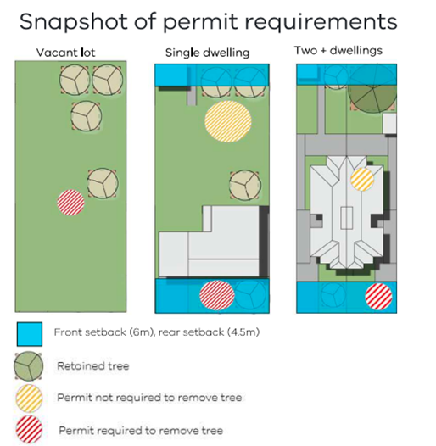

📍 What the image shows
The diagram explains permit triggers for:
🏡 Vacant lot
🏠 Single dwelling
🏗 Two or more dwellings
Key things to note:
🔵 Blue areas = Front setback (6 m) and rear setback (4.5 m)
🟢 Green trees = Retained trees
🟡 Yellow striped trees = Permit NOT required
🔴 Red striped trees = Permit REQUIRED
In most cases, in the Township Zone a planning permit is required to remove a canopy tree:
• On vacant land (anywhere on the lot)
• Within 6 m of the street frontage
• Within 4.5 m of the rear boundary
• When developing two or more dwellings

🌏 Why protect canopy trees?
Large trees help to:
🌳 Reduce urban heat
🌳 Improve neighbourhood character
🌳 Support biodiversity
🌳 Build climate resilience
They take decades to replace — protecting them now helps future generations.

Before removing or heavily pruning a large tree, contact Buloke Shire Council planning department on 1300 520 520 or by email planning@buloke.vic.gov.au to check if a planning permit is required.

