2024 Local Government Community Satisfaction Survey Results
Author’s Title: Acting Director Community Development
Department: Community Development File No: GS/02/01
Relevance to Council Plan 2021 - 2025
Strategic Objective: Our Council and Community Leadership

PURPOSE
To note the results of the 2024 Local Government Community Satisfaction Survey.

SUMMARY
The 2024 Local Government Community Satisfaction Survey Report is attached for Council to note.

The report is coordinated on behalf of all Victorian councils by the Department Jobs Precincts and Regions.

RECOMMENDATION

That Council:
- Notes the results of the 2024 Local Government Community Satisfaction Survey; and
- Publishes the results of the survey to the community.

Attachments: | 1 2024 Community Satisfaction Survey

DISCUSSION
The 2024 Local Government Community Satisfaction Survey is held annually and coordinated by the Department of Government Services on behalf of Victorian councils.

The survey provides an insight into the community’s views on:
- councils’ overall performance, with benchmarking against State-wide and council group results
- value for money in services and infrastructure
- community consultation and engagement
- decisions made in the interest of the community
- customer service, local infrastructure, facilities, services and
- overall council direction.
Buloke Shire Council’s overall performance rating, as well as ratings on most individual service areas, stabilised over the past 12 months after having experienced significant declines in the previous two years. Recreational facilities is a notable exception; ratings increased significantly in this area from 2023, whereas ratings declined in the area of business and community development and tourism. Despite the stabilisation in ratings, one-third of residents feel overall the council direction deteriorated over the last 12 months.

The overall performance index score of 49 for Buloke is unchanged from the 2023 result, stemming significant declines experienced in each of the two years prior. This is in contrast to the Small Rural group and State-wide trend, where perceptions continue to decline. Council’s overall performance remains lower than in 2021 when it peaked at 62 index points.

Council’s overall performance is rated statistically significantly lower (at the 95% confidence interval) than the average ratings for councils in the Small Rural group and State-wide (index scores of 53 and 54 respectively).

Council’s best performing areas were recreational facilities, waste management, appearance of public areas and emergency and disaster management. On the other hand, perceptions declined significantly in just one service area in 2024, business and community development and tourism. Council continues to rate lowest in the areas of the maintenance of unsealed roads (index score of 27) and sealed local roads (index score of 37).

A graphic representation of the summary of core measures, included in the survey report, is included below.
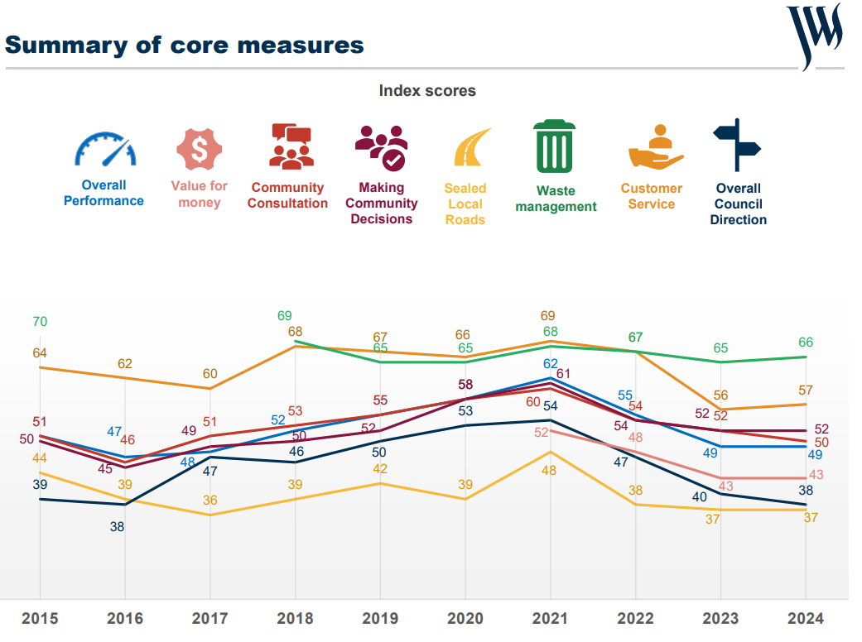

RELEVANT LAW
Not applicable.

RELATED COUNCIL DECISIONS
Not applicable.

OPTIONS
Not applicable.

SUSTAINABILITY IMPLICATIONS
Results of the survey may be used to inform decisions around sustainability.

COMMUNITY ENGAGEMENT
A telephone survey was conducted by JWS Research, who contacted random residents on behalf of
Council, that were 18 years or above, residing in Buloke Shire. Council advertised the approaching survey in local newspaper advertisements, on radio spots and on social media in the weeks leading up to the survey which was conducted in February of this year.

The results of the survey will be communicated with the public.

INNOVATION AND CONTINUOUS IMPROVEMENT
In noting this report, Council may consider future actions against results of the survey.

Council also received a briefing from JWS Research to review and understand the data that the survey results revealed.

COLLABORATION
The Executive Management Team collaborated with the Department Jobs Precincts and Regions and JWS research in preparation of the survey.

FINANCIAL VIABILITY
The cost of conducting the survey was as per the budget allocation made in Council’s Annual Budget 2023/24.

REGIONAL, STATE AND NATIONAL PLANS AND POLICIES
Local Government Act 2020

COUNCIL PLANS AND POLICIES
Not applicable.

TRANSPARENCY OF COUNCIL DECISIONS
Participation in the State-wide Local Government Community Satisfaction Survey is optional.

Participating Councils have various choices as to the content of the questionnaire and the sample size to be surveyed, depending on their individual strategic, financial, and other considerations.

CONFLICTS OF INTEREST
No staff member involved in the compilation of the report has a conflict of interest to declare.

