MEDIA RELEASE
Official Opening of Donald Children’s Centre
19 February 2016
The visually impressive Donald Children’s Centre located at 6-12 Houston Street will be officially opened on Friday 26 February 2016. The State Government Minister for Families and Children and Minister for Youth Affairs, the Hon Jenny Mikakos MP, together with the Federal Member for Mallee Mr Andrew Broad MP will be attending and speaking at the opening in conjunction with the Mayor of the Buloke Shire Council, Cr Reid Mather and other councillors.
Members of the public are welcome to attend the official proceedings and to take the opportunity to inspect the facility. The development of this children’s ‘hub’ has been made possible through funding from a range of sources including the Department of Education and Training, Regional Development Australia, Regional Development Victoria, the Buloke Shire Council, the Donald Kindergarten, and the wider Donald community.
“Buloke Shire thanks the federal and state government contributors as well as our local contributors for their foresight and assistance in making this facility a reality’, said Mayor, Cr Reid Mather.
“This is a wonderful facility catering for the needs of young families from Donald and surrounding districts. Many years ago the Donald community recognised a real need for a purpose built facility to replace the existing dilapidated kindergarten and one that could cater for the provision of a range of early years programs such as Maternal and Child Health, Child Care, Kindergarten, MOPS, Playgroups, immunisation services, and other visiting specialist early childhood services. It is the culmination of ten years of research, public consultation, lobbying for funding, planning and construction. The first intake of kindergarten students was in 2015 and now with the building occupied and functioning, it is fantastic to be finally officially opening the facility”, said Cr Reid Mather.
The Donald Children’s Centre is located at 6-12 Houston Street, Donald and official proceedings will begin at 11.00am with a morning tea to follow.
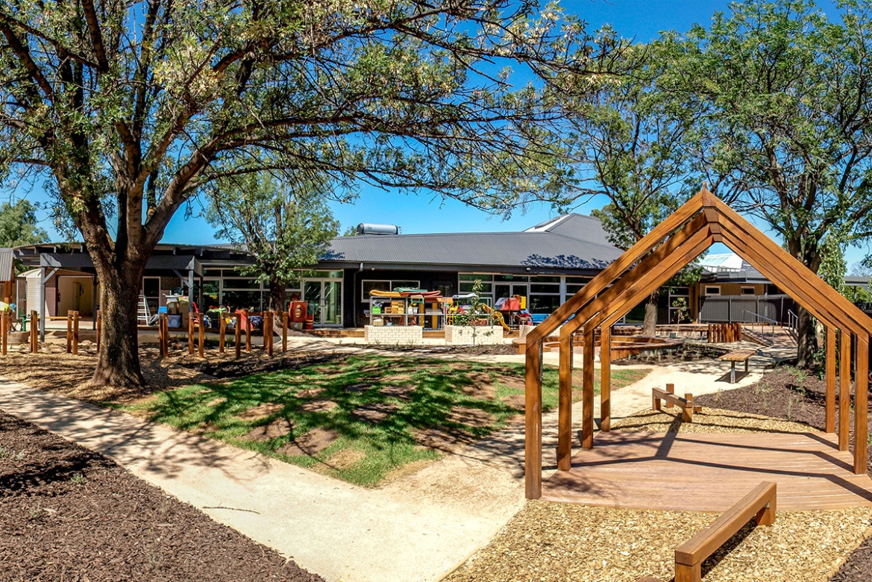
End release
For further information contact Travis Fitzgibbon on 1300 520 520

