MEDIA RELEASE
Cricket Victoria comes to the crease
5 February 2016
Local sporting clubs are one of the pillars of rural communities and support for local cricket teams remains strong as evidenced by the recent re- forming of the Watchem Panthers Cricket Club. Cricket, along with the other sporting activities, provides a wonderful opportunity for social connectedness and community involvement in these times of drought.
Cricket Victoria has got on the front foot to look what it can do with the resources at its disposal to help communities in the grip of drought. A community meeting was held in Wycheproof on 1 February as Cricket Victoria looks to put together a specific drought assistance program for Buloke Shire. Cricket Victoria representatives Tom Huf and Aaron Wharton, met with seventeen representatives from the cricket clubs of Buloke as well as a representative from Wimmera Mallee Cricket Association. The aim of this meeting was to determine the best way forward for Cricket Victoria to roll out its drought support program, having decided to work alongside Buloke, Gannawarra and Yarriambiack Shires, all of which have been severely impacted by the current drought.
Issues and priorities outlined within the meeting included; the condition of local grounds, availability and cost of water, challenges in maintaining strong volunteer numbers and quality coaching, challenges of engaging young people and families and the cost of travel for teams. Comments from the evening centred on the realisation that all clubs face very similar issues.
Cricket Victoria will now use information gathered from the meeting and come back with a proposal for a local support program. Cricket Victoria will continue to work in consultation with, Council, local cricket clubs, Wimmera Mallee and Mallee Murray cricket associations, as well as schools in developing a drought assistance program that will be sustainable over an extended period, as it was well recognised that the issues raised were not restricted to periods of drought.
Cricket Victoria is planning to hold a special weekend event at Nullawil on the final weekend of competition in February. More details to come.
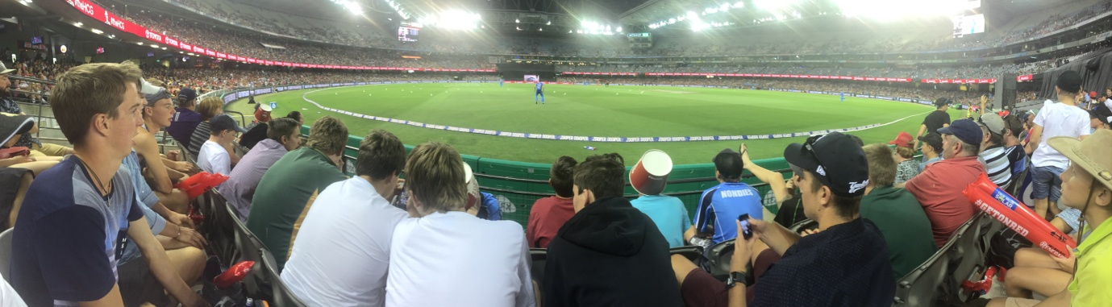
Already there has been one relationship highlight with forty Buloke residents attending the Melbourne Renegades v Adelaide Strikers Big Bash League fixture on 18 January. This was made possible through Cricket Victoria and Melbourne Renegades with forty reserved seats at Etihad Stadium and state government support through the Local Government Drought Response program for a bus to travel to the match. Ticket allocations were made through local cricket clubs who acted swiftly at short notice.
“Thanks to all those local cricket contacts who worked hard to ensure that their members had the opportunity to benefit from the initiative. The night was a huge success for all involved and thoroughly enjoyed. Unfortunately the Renegades couldn’t get the win despite the clean hitting of Chris Gayle. We appreciate the generosity and interest of both Cricket Victoria and the Melbourne Renegades for their support of the evening”, said Mayor, Cr Reid Mather.

End release
For further information contact Travis Fitzgibbon on 1300 520 520

